Calming Hand

The Calming Hand is a particularly helpful tool when you suffer with feelings of panic. It also works well with episodes of breathlessness, when you feel like your breathing is out of control.

- Recognition/ Acceptance Firstly recognise the signs that you are starting to panic. Hold your thumb firmly and remind yourself of what to do next to regain control. This will help to calm your breathing.
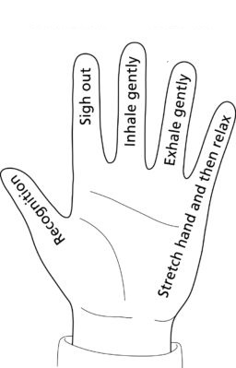
2. Sigh out Sigh out, as this relaxes your shoulders, arms, and upper chest (remember to flop and drop). If possible, try to breathe out for longer than you breathe in.

3. Inhale Take a slow and gentle relaxed breath in, focusing on filling your lungs with air

4. Exhale Then, take a slow and gentle relaxed breath out, until your breath comes to its natural end. Relaxed breathing helps to relieve the sensation of breathlessness.

5. Stretch hands, relax and stop Stretch and relax your hand, as a reminder that you can and will regain control. Hand stretching is helpful when having an episode of panic.

